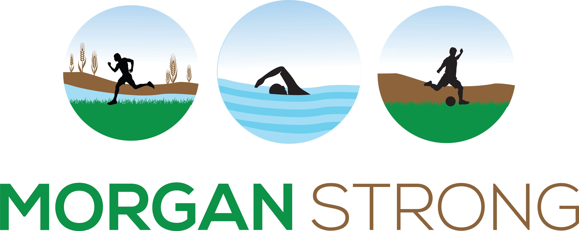

MORGAN MILLION GRANT APPLICATION

SUBMISSION DEADLINE: AUGUST 31, 2020

WHO WE ARE
We are a group of Morgan County residents who are passionate about recreation.
We want to make recreation better, bigger, and more accessible.
We created a non-profit organization built around this idea and meet regularly with local leaders to make it happen.

OUR SLOGAN
Everyone Plays.

We’re serious about bringing recreation to every resident in Morgan County.

OUR MISSION
Connecting Morgan County residents of all ages to fun, affordable, and expansive recreation.

We want the world to know that recreation is supposed to be fun and within reach for everyone.

FUNDING GOAL
COVID-19 related safety precautions have disrupted typical recreation in Morgan County. Morgan Strong believes recreation is still critical and that our community needs recreation more than ever. This grant will help local organizations which serve Morgan County residents, especially low-income youth and families with limited English proficiency.

FUNDING DESCRIPTION
- Funding will support private, non-profit, and government organizations that provide recreation services to youth.
- Youth are defined in this application as Morgan County youth, 21 years and younger.
- Recreation is defined as any enriching activity that supports youth physical, social, and emotional health.
- Awards may support free events, reduced tuition or rates, free enrollment, and related operating costs to free events for youth.
- Awards are $500 - $5,000.

TIMELINE

- Submit this completed document to info@morganstrong.org by August 31, 2020.
- Applications will be reviewed by Board Members of Morgan Strong and assessed using a standardized rubric. Applicants will be contacted about funding status by September 15, 2020.

SECTION I: TELL US ABOUT YOUR ORGANIZATION

ORGANIZATION NAME

ORGANIZATION MAILING ADDRESS

ORGANIZATION WEBSITE

MAIN CONTACT FOR GRANT [FIRST NAME, LAST NAME]

MAIN CONTACT EMAIL ADDRESS

WHAT IS YOUR MISSION?

HOW DO YOU CURRENTLY PROVIDE RECREATION TO MORGAN COUNTY YOUTH?

HOW MANY YOUTH DO YOU CURRENTLY SERVE?

DO YOU HAVE A REDUCED RATE FOR LOW-INCOME YOUTH?

IF YES, HOW DO YOU DETERMINE LOW-INCOME?

DO YOU WORK TO ENGAGE FAMILIES WITH LIMITED ENGLISH PROFICIENCY?

IF YES, EXPLAIN YOUR ENGAGEMENT EFFORTS.

WHAT ARE YOUR CURRENT EFFORTS TO MAINTAIN A SAFE ENVIRONMENT?
(Limit class sizes, physical distancing, providing masks, etc.)

SECTION II: TELL US ABOUT YOUR PROPOSAL

REQUESTED AMOUNT ($500 - $5000)
$

HOW WILL YOU USE THE FUNDING?
- Scholarships (No fee for participating youth)
- Reduced Fees (Reduce fees for all participants or eligible youth with set eligibility criteria)
- Free programming (No fees)
- Other:

WHAT IS THE OVERALL GOAL OF YOUR PROPOSAL? DESCRIBE THE EVENT OR ACTIVITY.

HOW WILL YOU MAKE IT HAPPEN?

HOW IS YOUR PROPOSAL INNOVATIVE? HOW WILL IT REACH FAMILIES WHO ARE UNDERSERVED IN RECREATION OPPORTUNITIES?
(Consider barriers like transportation, cost, language barrier, limited space, etc.)

INCLUDE A SHORT BUDGET DESCRIPTION HERE.
(Items to consider: translation services, equipment, staffing, promotion activities, etc.)

THANK YOU FOR YOUR APPLICATION.

